NATIONAL UNIVERSITY OF MODERN LANGUAGE ISLAMABAD
Lab 07


Submitted to:
Sir Hassan Shah
Submitted by:
Zulqarnain Hassan
Roll No: …………………… SP21379
Subject: …………………… computer network
Department: ……………… BSSE-5-Afternoon
Date: ……………………… 06-12-2024

Objectives:
- Using CDP protocol to find out neighbour information in Cisco packet tracer.
- Setting up a DHCP server in Cisco packet tracer.
- Configure a WEB server in the Cisco packet tracer and access the internet.
- Configuring DNS server.
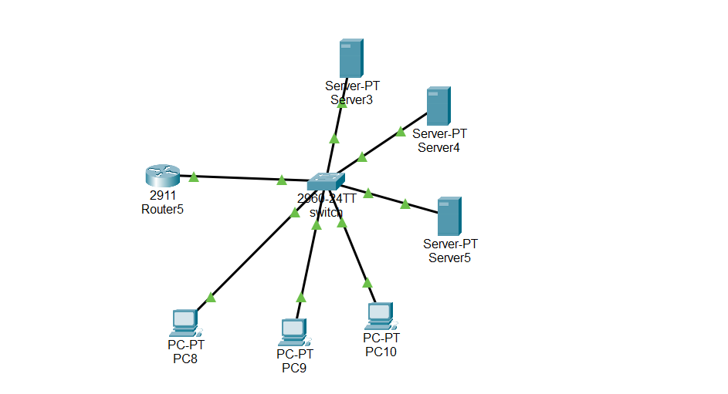

Task 1
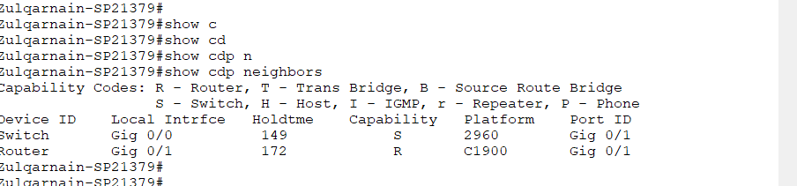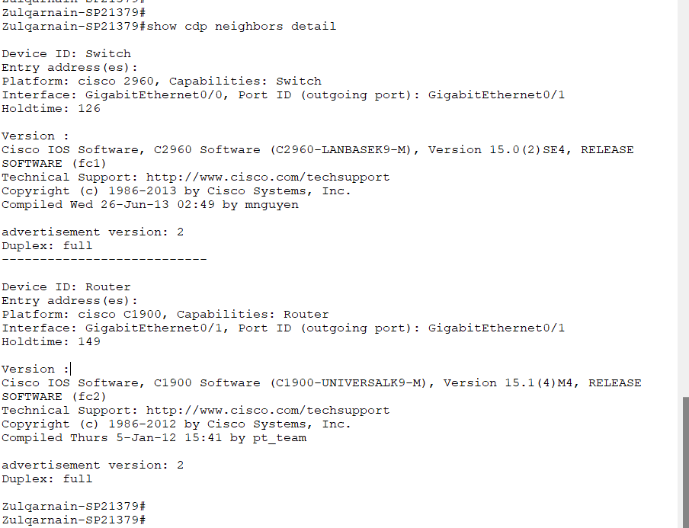

Task 3
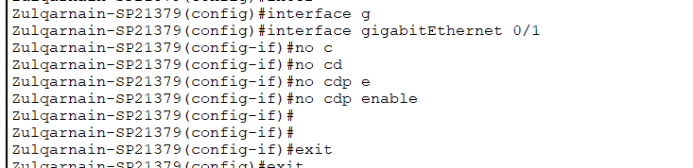

Task 4
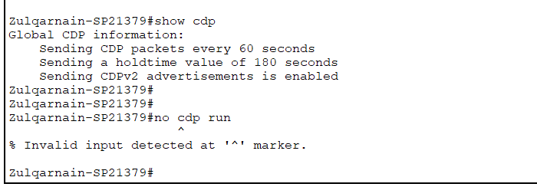
DHCP
Task 5
Configure the router for DHCP on the given IP addresses and connect a switch and three PCs. To obtain IP addresses from DHCP, open the IP configuration on the PC. Attach a screenshot of the PCs receiving IP addresses through DHCP.
Configuring router
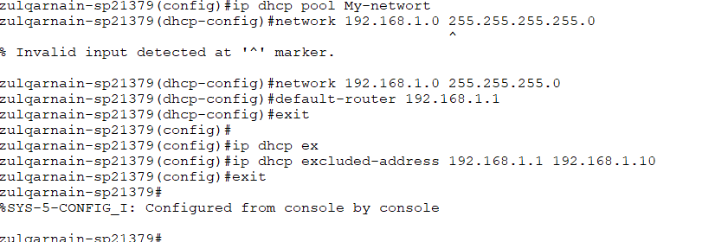
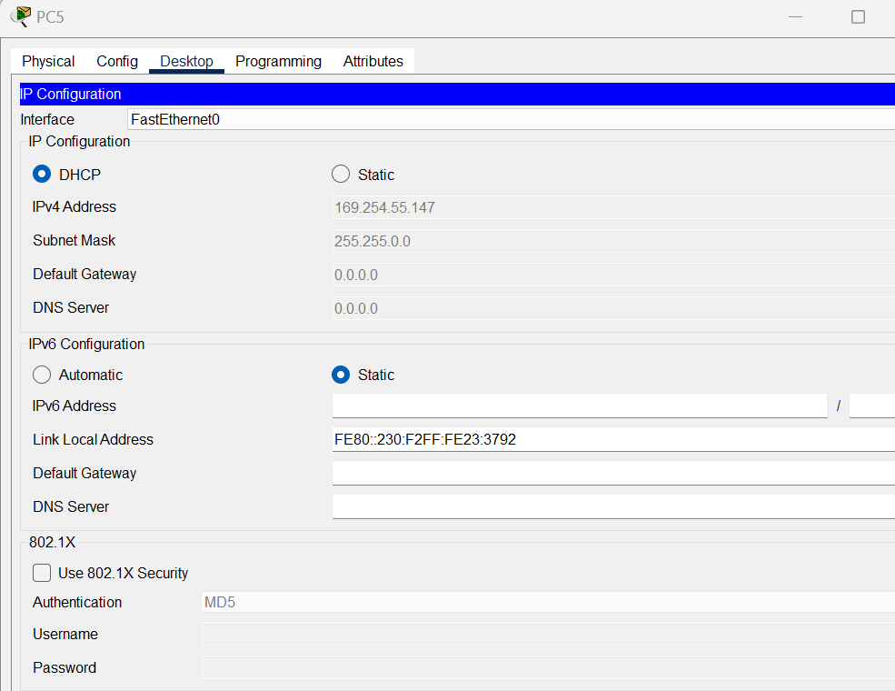

WEB SERVER
Task 6
Add different servers to other sites and access those sites on the PC browser. Attach a screenshot of the PCs accessing these sites.

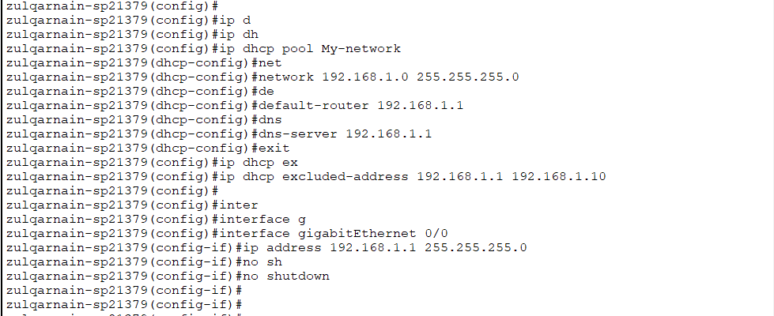
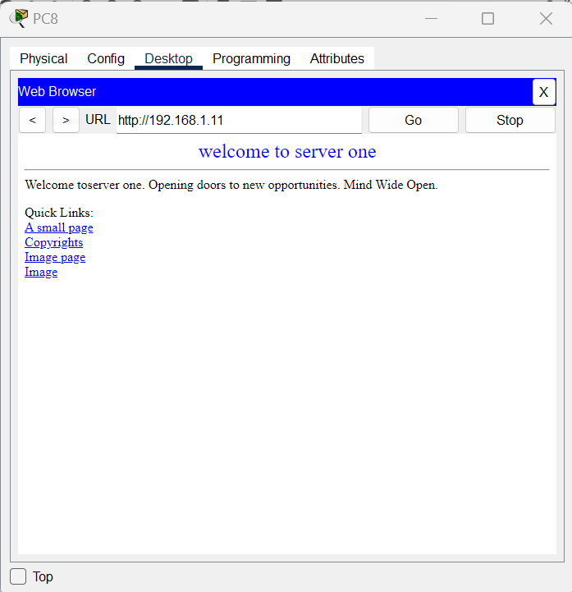
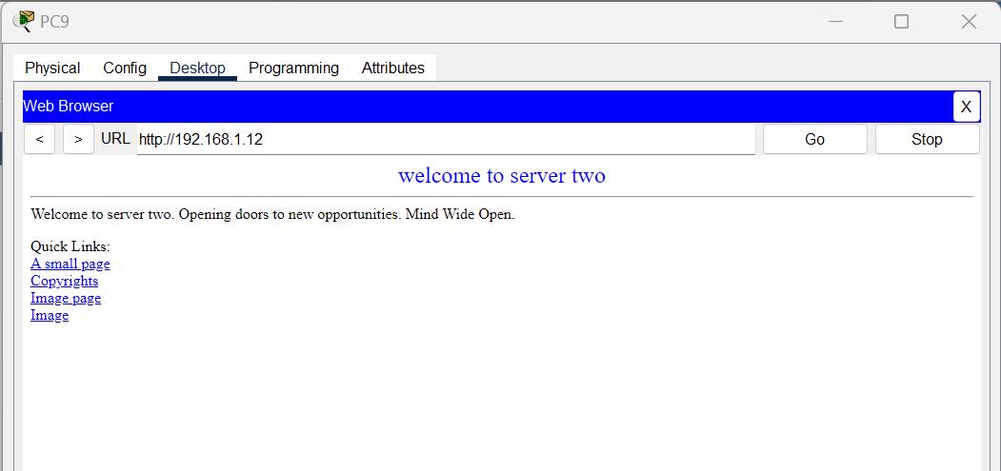

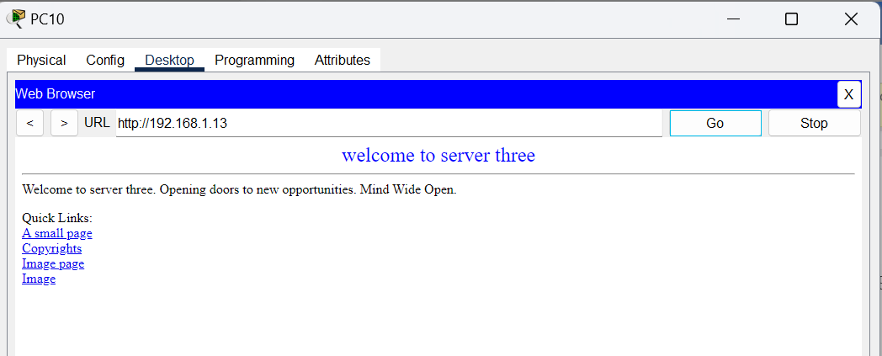

DNS
Task 7
Create a mapping for the switch in the server so that PCs can ping the switch with the name ‘switch’.
